**Project Synopsis:**

Driving around after arriving at a mall or a multiplex is annoying while searching for a parking spot is nerve-wracking. A truly smart solution to this can be an IoT based cloud integrated smart parking system. This design makes the traditional concept of parking system smarter by leveraging the power of IoT and embedding it with the latest innovation such as IR sensors with microcontroller. It is able to collect the information about the occupancy status of parking spaces of different areas, and there by drivers can search for the nearest parking slot by customized software application and web page. This idea mainly focuses on reducing the time involved in finding parking lots and also on avoiding Unnecessary travel through filled parking lots in a parking area. Towards the end, the paper also discusses the working of the system in form of a use case that proves the correctness of the proposed model.

**Material & Methods:**

Raspberry Pi 3, IR Sensors, Cloud Platform, Python Code.

**Innovation:**

The main Innovation of this project is that we have used a Raspberry pi 3, which Linux based Operating System making it most secure & open source. We have used a Cloud instead of a conventional or regular database. By using cloud we made it more secure and easy to access from anywhere. We have developed a Website & a mobile application for users which makes them easy to use services offered by our smart parking system.

**Result:**

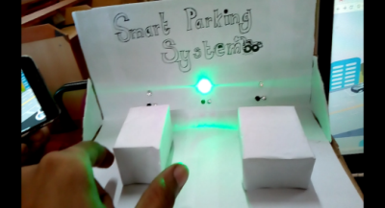

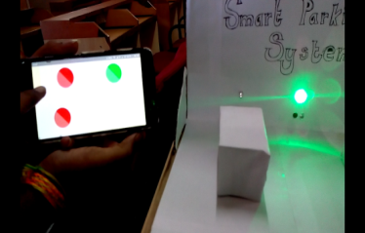

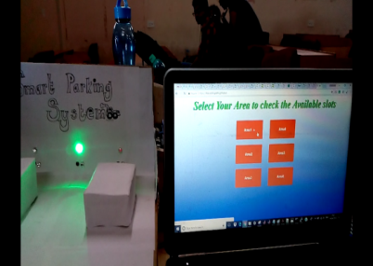

**Project Conclusion:**

This study has proposed an IoT based smart parking system which is more advantageous than the traditional parking system. The system helps in reducing the number of peoples who fail to park successfully, thus reducing the urban traffic congestion, pollution etc. The proposed system has been successfully implemented. The Results shows that the waiting period of drivers has been drastically reduced. The system can also be implemented on large scale. The system thus helps in upgrading the lifestyle of common people.

**Project Objective:**

To propose a solution for the conventional parking & to introduce a advanced and smart solution. Using IoT we are providing solution.

**Future Enhancements:**

Parking reservation

GPS based directions

RFID based Security

Camera Module